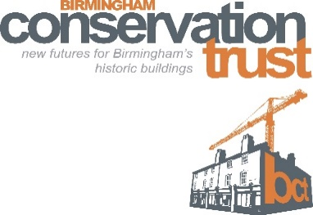

Conservation Help Enquiry Form

Please tell us about you and your conservation issue
Your name: |  | Contact number:
Company  If applicable |  | Email address:
What is the address of the building or area in Birmingham you are enquiring about?
What is the status of the building/ area in question?
Listed Conservation Area Registered Park or garden Don’t know
What use do the buildings have currently?
Residential Commercial Offices Other
Are you the building’s…….?
Owner Owner occupier Tenant Interested person
What is nature of your enquiry? How can we help?
Please email the completed form to: vicki@birminghamconservationtrust.org

